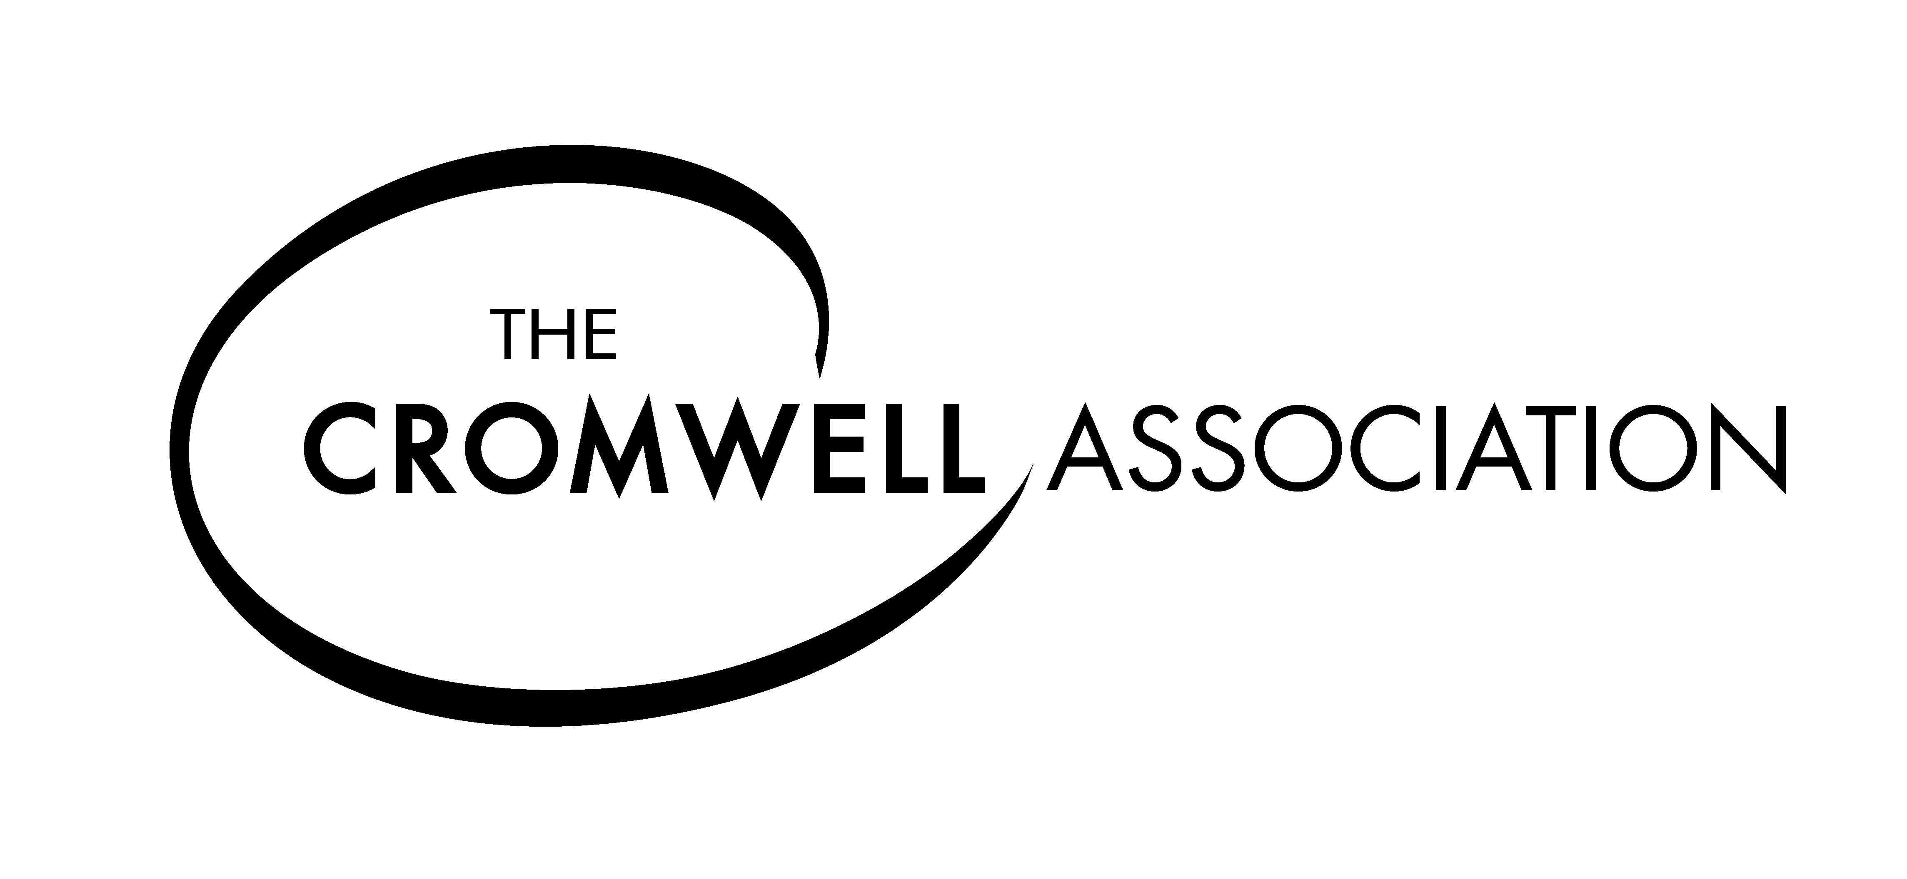
Cromwell Association membership application
The subscription year commences on 3rd September. All memberships are annual, and no life memberships are available. The Association welcomes payment by Standing Order through your bank. Please indicate below if you would like to pay by this method for future years.
Categories of membership – please indicate which you are applying for:
Individual membership UK £20.00 Yes/No
Individual membership non-UK £25.00 Yes/No
Additional members at same address £5.00 Yes/No
Institutional/corporate UK £30.00 Yes/No
Institutional/corporate non-UK £40.00 Yes/No
Schools/College UK £50.00 Yes/No
Schools/College non-UK £55.00 Yes/No
_________________
Payment – cheque enclosed £__________________
Cheques payable to The Cromwell Association in pounds sterling . Thank you.
For non-UK applicants payment via the PayPal option on the website at www.olivercromwell.org may be the most convenient option.
Please complete your details below in BLOCK CAPITALS
Name………………………………………………………………………………………… (Mr/Mrs/Ms/ Dr/Prof/Rev)
Address………………………………………………………………………………………….
……………………………………………………………………………………………………….
………………………………………………………………………………………………………
Post code…………………………….email address…………………………………………………………………..
Please send me a Standing Order Instruction (for annual payment through your bank in future) Yes/No
Please return the completed form and payment to:The Cromwell Association, c/o Cliffe Hanger, Cuilfail, Lewes, BN7 2BE:for UK tax-payers please see Gift Aid declaration overleaf
GIFT AID DECLARATION – for past, present and future donations
THE CROMWELL ASSOCIATION Registered Charity No: 1132954
Please treat as Gift Aid donations all qualifying gifts of money and membership subscriptions made by me to The Cromwell Association in the previous four years and any that I may make in the future until I notify you otherwise.
I confirm I have paid or will pay an amount of Income Tax and/or Capital Gains Tax for each tax year (6 April to 5 April) that is at least equal to the amount of tax that all the charities or Community Amateur Sports Clubs that I donate to will reclaim on my gifts for that tax year. I understand that other taxes such as VAT or Council Tax do not qualify. I understand the charity will reclaim 28p of tax on every £1 that I gave up 5th April 2008 and will reclaim 25p of tax on every £1 that I give on or after 6th April 2008.

Date...................................... Signature................................................................................
Donor’s Details
Title................First name or Initial(s)..............................
Surname.............................................
Home Address...............................................................................................................
......................................................................................................................................
.......................................................................................................................................
Postcode...................................
Please notify the Association if you:
-Want to cancel this declaration
-Change your name or home address
-No longer pay sufficient tax on your income and/or capital gains
If you pay Income Tax at the higher or additional rate and want to receive the additional tax relief due to you, you must include all your Gift Aid donations on your Self Assessment tax return or ask HM Revenue and Customs to adjust your tax code
Please return the completed declaration form to:
The Cromwell Association, c/o Cliffe Hanger, Cuilfail, Lewes, BN7 2BE

