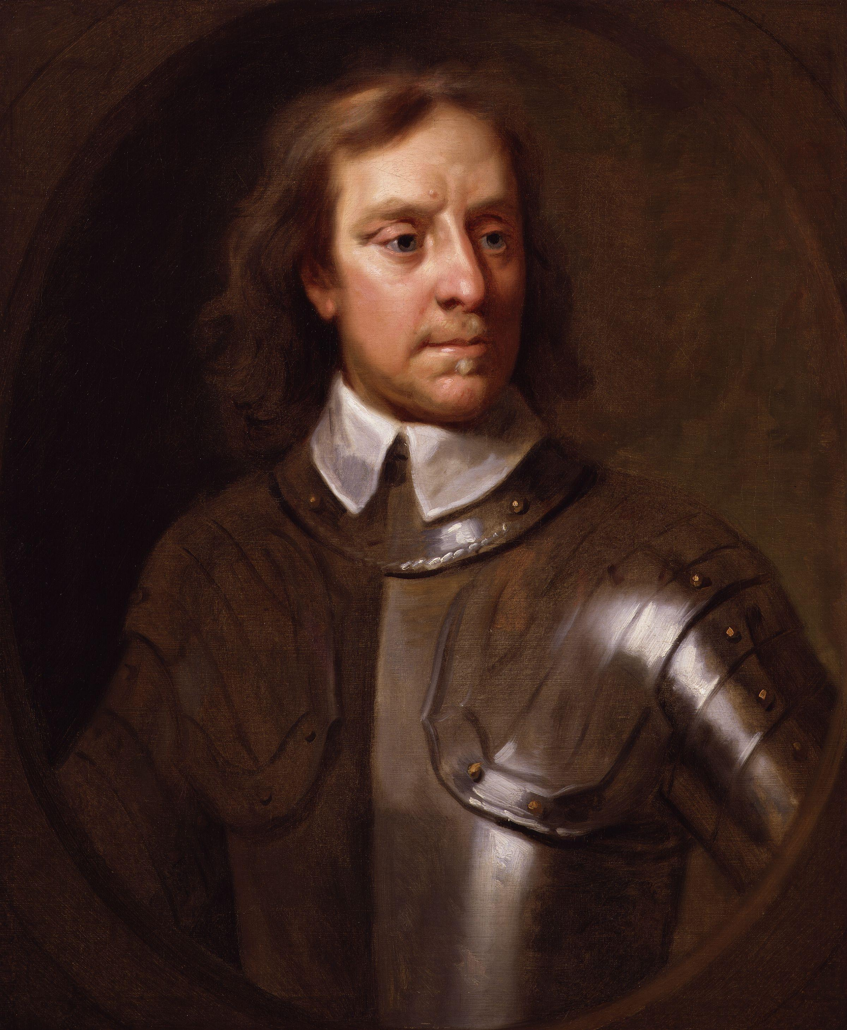
Oliver cromwell: a brief biography
Oliver Cromwell was born on 25th April 1599 in Huntingdon. His family were fairly important in the local area, and he studied at Cambridge University. He became a Member of Parliament for Huntingdon in 1628. In the 1630s Cromwell became very religious and was convinced that he would be guided to carry out God’s purpose. He began to make his name as a radical Puritan (people who were very strict in their religion) when he was elected to represent Cambridge in Parliament in 1640.
Civil War broke out between the King, Charles I, and parliament in 1642. Although Cromwell lacked military experience, he soon learned. He led a superb force of cavalry, known as the Ironsides, and rose from the rank of captain to that of lieutenant-general in 3 years. He convinced parliament to establish a professional army, the New Model Army, which beat the King’s forces at Naseby in 1645. The King lost the Civil War, and this, along with the general actions of the king, convinced Cromwell that the king needed to be brought to justice. He was a key figure in the trial and execution of the king in 1649. Cromwell went on to become the army commander, and got rid of resistance in Ireland.
In 1653 Cromwell got rid of the Parliament that had been running the country. He tried to set up another one, but when this failed he made himself Lord Protector. Some people thought he should become King, but he refused the crown in 1657. He tried to introduce more morals into society in England, and worked hard to end wars between England and other European countries. Cromwell died on 3rd September 1658 in London. In 1660 the son of Charles I was made King. He ordered Cromwell’s body to be dug up and hanged to show that Cromwell was a traitor.

