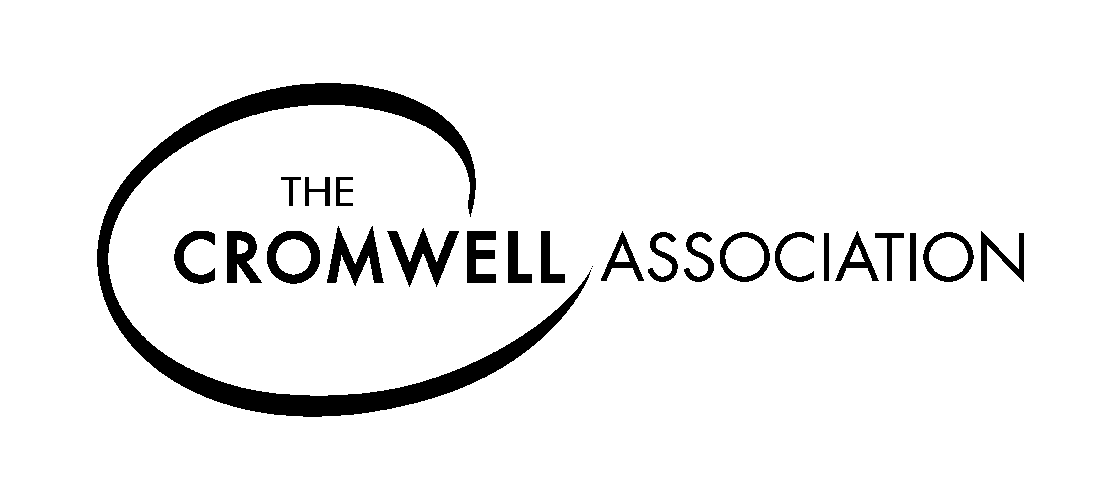
THE CROMWELL ASSOCIATION ANNUAL MEMBERSHIP
To apply to join the Association please complete the form below. The subscription year runs from 3rd September each year and a renewal notice will be sent with your summer mailing. If you join after2nd June the membership will run until 2nd September of the following year, but you will not receive the annual journal for the year in which you join. A hard copy can be purchased at a discounted price.
ANNUAL MEMBERSHIP £
Adult ( UK £ 20 / Overseas £30)
Additional members at same address ( £5 each )
Institutional / Corporate Member ( UK £30 / Overseas £45 )
Schools (Free for 2017/18 –£10 if you want to receive hard copy mailings)
DONATIONS are welcome to assist us further
___________________
TOTAL PAYMENT- CHEQUE ENCLOSED ____________________
CHEQUES TO BE MADE PAYBLE TO “ THE CROMWELL ASSOCIATION ” All payments to be made in POUNDS STERLING.
Please complete your details below in BLOCK CAPITALS delete as appropriate.
Name................................................................................................................ Title Sir/Rev/ Dr/ Prof/Mr/Mrs/Ms
Address...............................................................................................................................................
......................................................................................................................................................
Postcode.................................... Email Address............................................................................................*
* Please note email addresses are not divulged to third parties and are only used for communicating to members between our hard copy mailings
ADDITIONAL NAMES at the same address ( family and other members )..................................................
.............................................................................................................................................................
A membership card/s will be enclosed with your Membership Pack. We aim to send these out as quickly as possible. If you have not received anything within 21 days please contact us further at the address below.
Please return your completed form with payment to, THE CROMWELL ASSOCIATION, Cliffehanger, Cuilfail, Lewes, BN7 2BE
For Gift Aid Declaration please see overleaf. If you are a UK Tax-payer please complete the form .
GIFT AID DECLARATION – for past, present and future donations
THE CROMWELL ASSOCIATION Registered Charity No: 1132954
Please treat as Gift Aid donations all qualifying gifts of money and membership subscriptions made by me to The Cromwell Association in the previous four years and any that I may make in the future until I notify you otherwise.
I confirm I have paid or will pay an amount of Income Tax and/or Capital Gains Tax for each tax year (6 April to 5 April) that is at least equal to the amount of tax that all the charities or Community Amateur Sports Clubs that I donate to will reclaim on my gifts for that tax year. I understand that other taxes such as VAT or Council Tax do not qualify. I understand the charity will reclaim 28p of tax on every £1 that I gave up 5th April 2008 and will reclaim 25p of tax on every £1 that I give on or after 6th April 2008.

Date...................................... Signature................................................................................
Donor’s Details
Title................First name or Initial(s)..............................
Surname.............................................
Home Address...............................................................................................................
......................................................................................................................................
.......................................................................................................................................
Postcode...................................
Please notify the Association if you:
-Want to cancel this declaration
-Change your name or home address
-No longer pay sufficient tax on your income and/or capital gains
If you pay Income Tax at the higher or additional rate and want to receive the additional tax relief due to you, you must include all your Gift Aid donations on your Self- Assessment tax return or ask HM Revenue and Customs to adjust your tax code
Please return the completed declaration form to:
The Cromwell Association, c/o Cliffe Hanger, Cuilfail, Lewes, BN7 2BE

